[Figures] Politics, pleasure, violence: Swedish Defence propaganda in social media

Rodrigo Ferrada Stoehrel, PhD Candidate
Department of Culture and Media Studies
Umeå University, Sweden
rodrigo.ferrada@umu.se

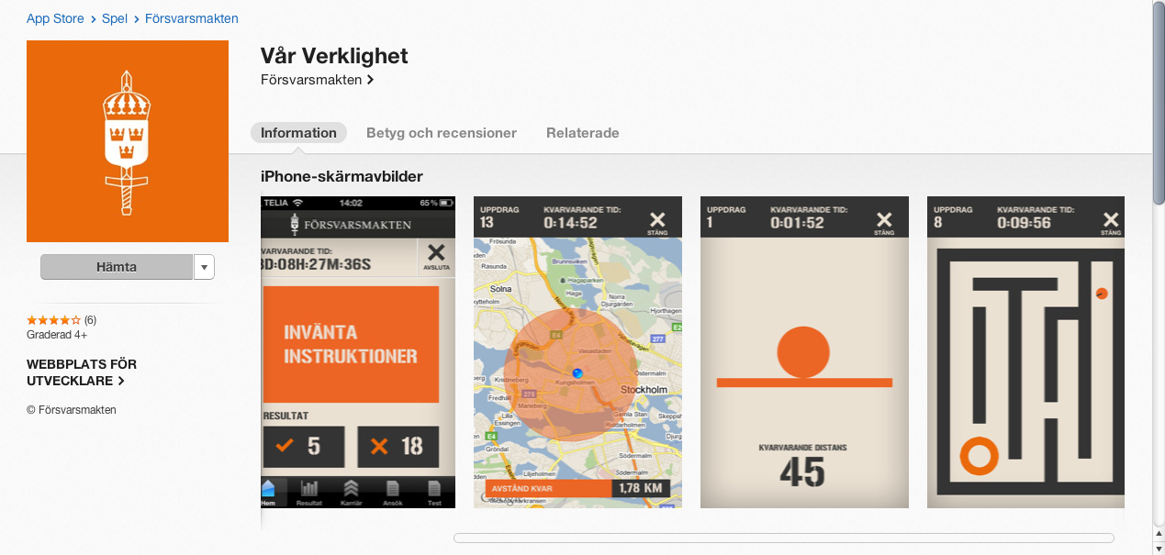

Figure 1. Screenshot from the Armed Forces’ app Our Reality.

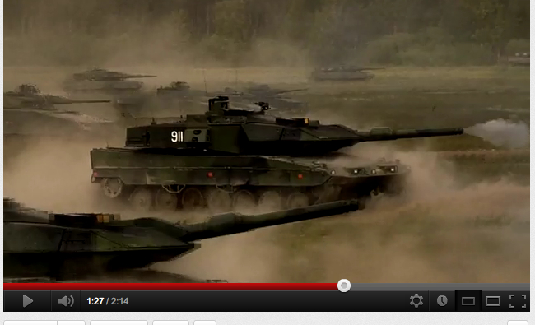
Figure 2. Frame from the film ‘The World’s Greatest Main Battle Tank – Stridsvagn 122.’
Photo: Combat Camera, the Swedish Armed Forces.

