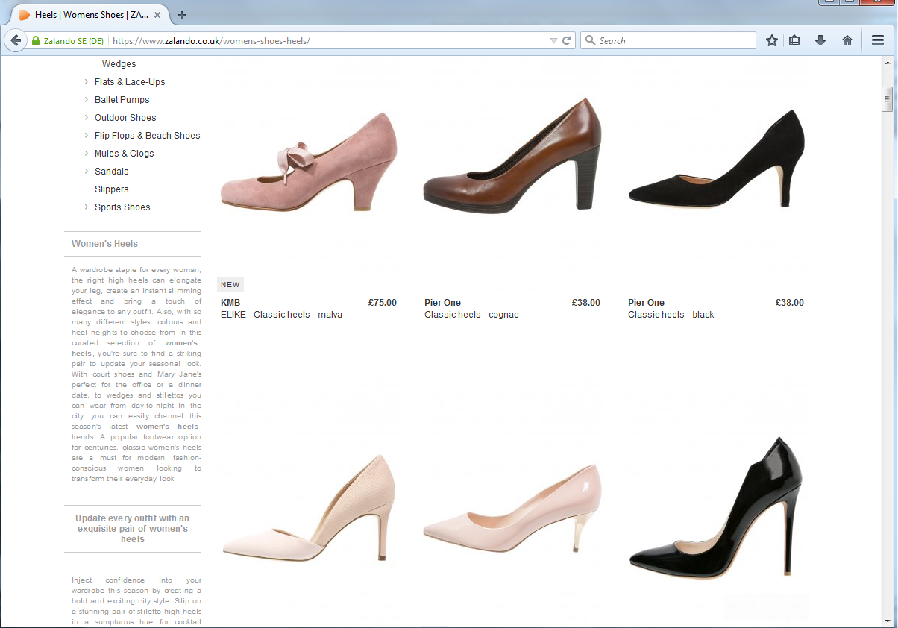
Figur 7: Screen shot af katalog for ’Women’s heels’

