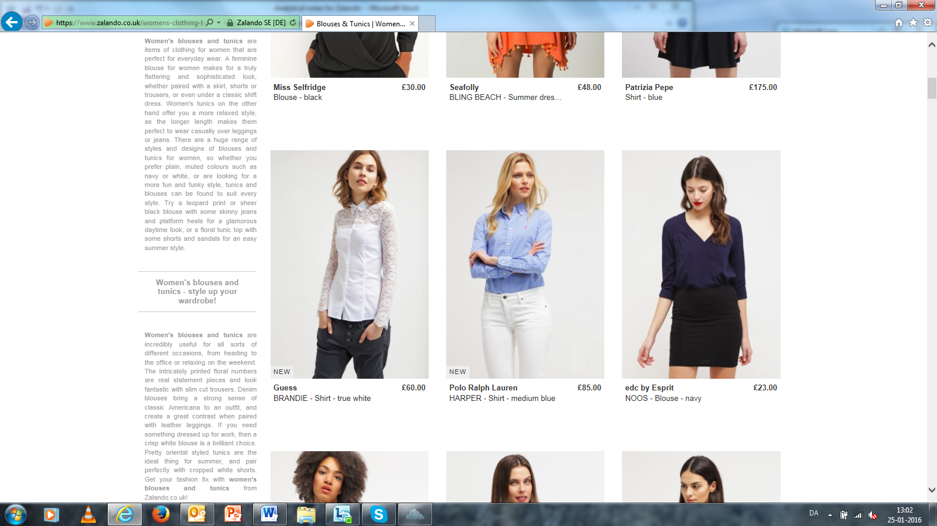

Figur 5: Screen shot af katalog for ’Women’s blouses and tunics’