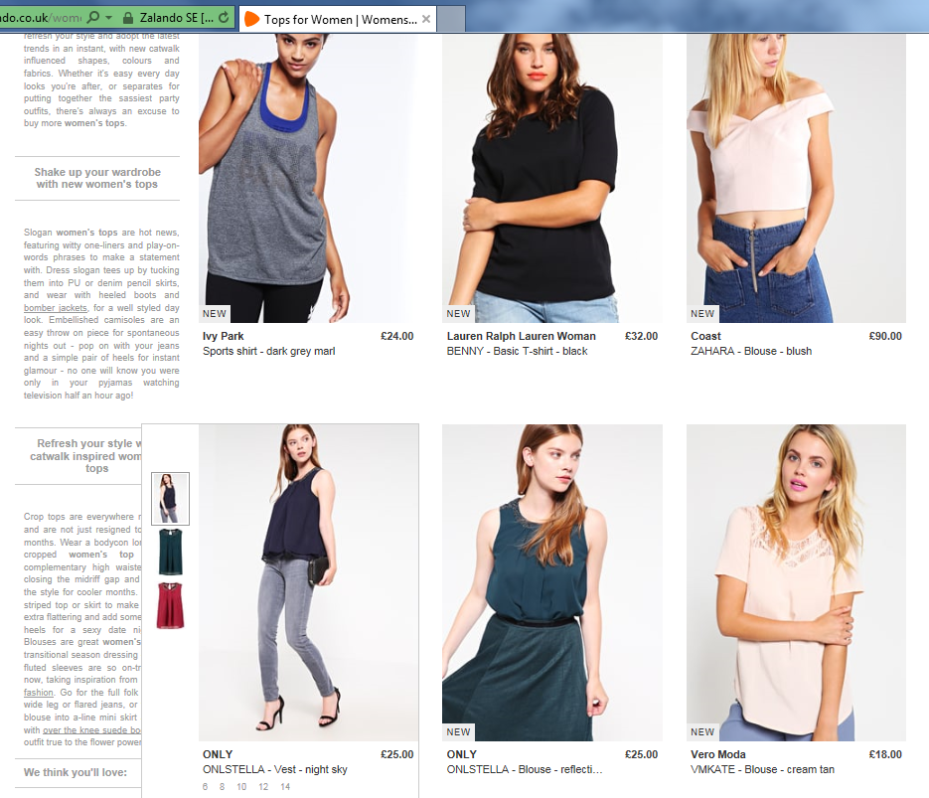
Figur 3: Screen shot af katalog

