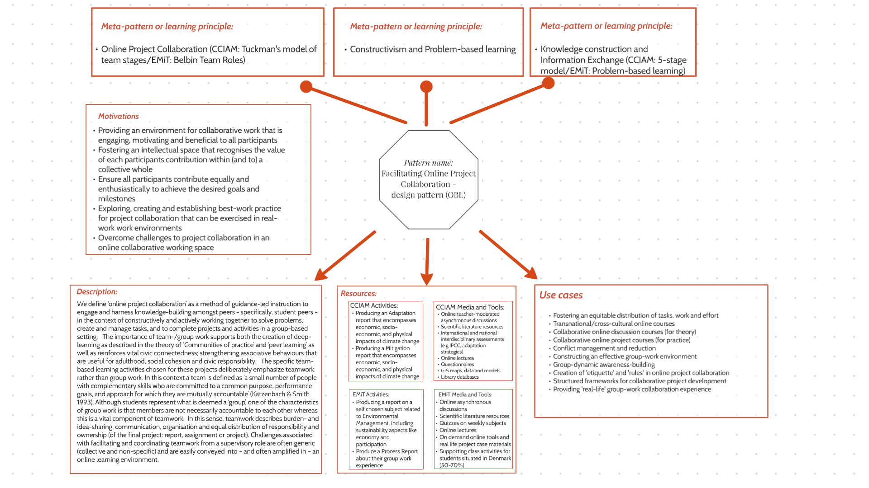
Appendix 2: Learning design for Facilitating Online Project Collaboration

