Title, Times Roman 16

First Name Last Name, First Name Last name … (if from same institution)

Institution, City, Address

[Author1Emailaddress@institution1.net](mailto:Author1Emailaddress@institution1.net), [Author2Emailaddress@institution2.net](mailto:Author2Emailaddress@institution2.net)

First Name Last Name (if from different institution)

Institution, City, Address

[Author1Emailaddress@institution1.net](mailto:Author1Emailaddress@institution1.net)

**Abstract**: Abstract style in Times New Roman 11 point, indented 1.0cm to the left and right of the margins. Abstracts should be no more than 250 words. The abstract should describe the main findings of the paper. This is an example of the abstract style.

**Keywords**: Keyword or phrase, keyword or phrase, keyword or phrase (maximum of 4).

Heading level 1: 14 point, Times Roman, 18 point before, 12 after

Body text style in Times New Roman 12 point. This is an example of the body text. Spacing between paragraphs should be 6 point, Right Margin. This is an example of a paragraph using the body text.

This is an example of the body text style. This is an example of the body text:

* Example level 1 bullet list
  + Example level 2 bullet list

Heading level 2: 12 point, Times Roman, 12 point before, 6 point after

Body text style in Times New Roman 12 point. This is an example of the body text. Spacing between paragraphs should be 6 point, Right Margin.

Table 1. Example caption/title for table

|  |  |  |  |  |
| --- | --- | --- | --- | --- |
| Table heading 1 | Table heading 2 |  | Table heading 3 | Table heading 4 |
| Content | Times Romans 11 |  |  |  |
|  |  |  |  |  |

Heading level 3 style

Figures should be centred, with centred caption below. They need to be referenced in the text, using automatic cross-referencing as shown here in this example (see Figure 1).

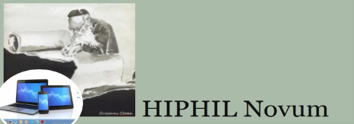

Figure **1**. Example caption/title for figure.

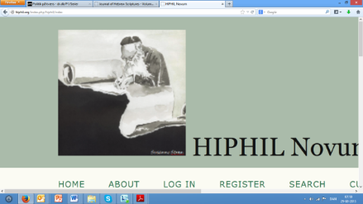Small figures can also be place in a floating text box at the side of the text, using a textbox, so that space can be used more economically. An example is shown in Figure 2. Also here the figure needs to have a caption that is referenced in the text.

**Figure 2. In floating text box, 0 point before, 6 point after**

This is an example of the body text style. This is an example of the body text style. This is an example of the body text style. This is an example of the body text style. This is an example of the body text style. This is an example of the body text style.

This is an example of the body text style. This is an example of the body text style. This is an example of the body text style. This is an example of the body text style.

This is a quotation. It uses the quotation style in Times New Roman 11 point, indented 1.0 cm to the left and right of the margins. References preferably in Author-Date style. (Reference, year)

Notes appear in the text as footnotes, preferably also hyperlinks in notes.[1]

### Acknowledgements

Acknowledgements appear in body text style in Times New Roman 12 point. This is an example of acknowledgements in body text style.

### Bibliography, preferred

HIPHIL Novum recommends the author-date system with references in the text, e.g. Lehman (1993) points out, or as argued (Lehman 1993: 1).

### References

Times Roman, Point 11, 0 Point before, 3 Point after. SBL Style is to be followed.

Allegro, J. M. 1955. “Uses of the Semitic Demonstrative Z in Hebrew.” *Vetus Testamentum* 5: 309-312.

Blau, Joshua. 2010. *Phonology and Morphology of Biblical Hebrew*. Linguistic Studies in Ancient West Semitic 2. Winona Lake: Eisenbrauns.

Comrie, Bernard, Matthew S. Dryer, David Gil, and Martin Haspelmath. 2005. “Introduction.” Pages 1-8 in *The World Atlas of Language Structures*. Edited by Martin Haspelmath, Matthew S. Dryer, David Gil, and Bernard Comrie. Oxford: Oxford University Press.

Waltke, Bruce K. and Michael. O’Connor. 1990. *An Introduction to Biblical Hebrew Syntax*. Winona Lake: Eisenbrauns.

### Bibliography, alternative

We do allow, however, for the traditional SBL system to be used:

In his book *Changing our Textual Minds*,[2] Adriaan van der Weel …. [3]

1. Times Roman 11 in notes, 0 Point before, 3 Point after, Right Margin. Hyperlinks in notes, e.g., <http://hiphil.org/> (accessed January 1, 2014).
2. Adriaan van der Weel*, Changing our Textual Mind: Towards a Digital Order of Knowledge* (Manchester: Manchester University Press, 2011).
3. Cf. van der Weel, *Changing our Textual Minds*, 69.