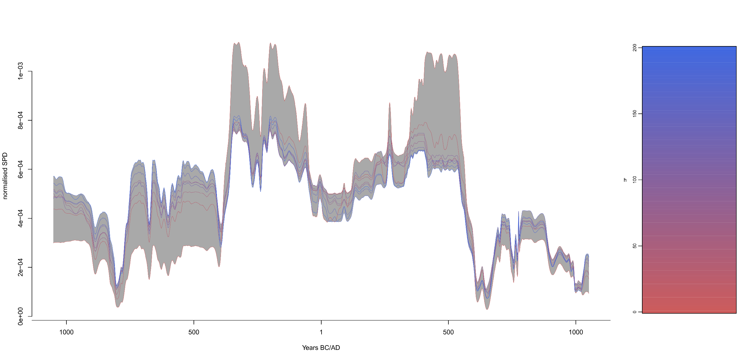
Figure S3.1: Sensitivity testing the effect of bin-height using the rcarbon binsense() funtion with a parameter range for h spanning 0 to 200 in 25 years intervals. Effectively, the results show that, with the data used here, the overall SPD trends are robust to the choice of bin-height.

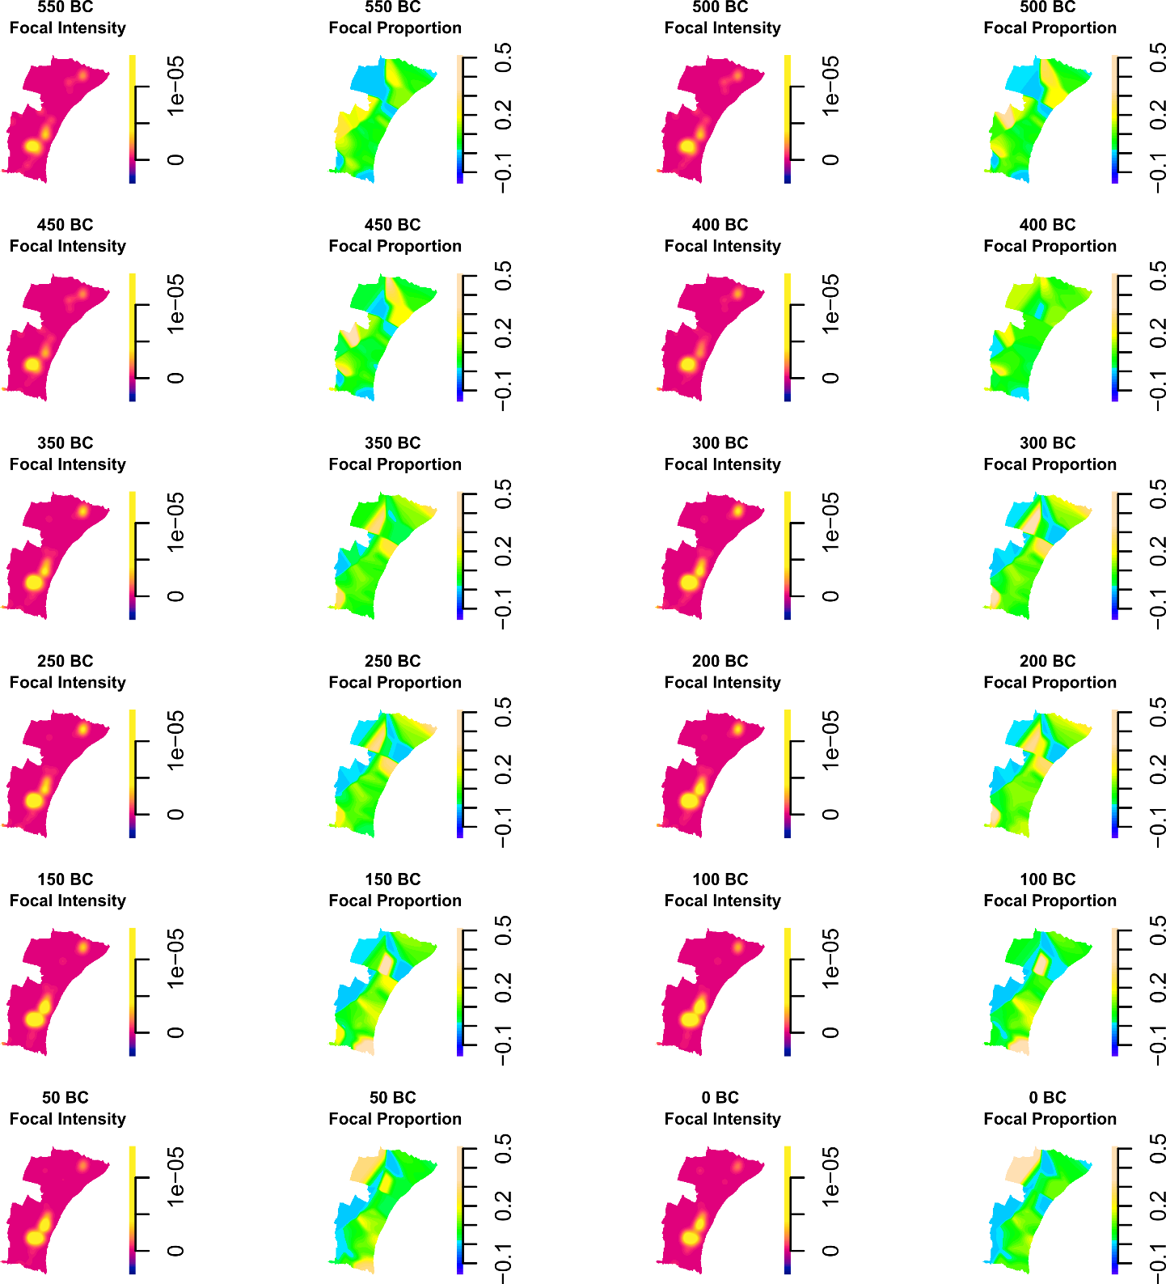
Figure S3.2: Supplementary plots of spatiotemporal densities of the settlement radiocarbon data in 50-years timeslices. Here, the Focal Intensity panels replicate those in Figure 7 in the main text, while Focal Proportion panels express the spatial density distribution of radiocarbon observations in each focal time slice relative to their distribution across the full temporal range of the input data. This helps to control for differences in the spatial intensity of the overall sample. Here, the plots show instances of relatively high focal proportions occurring in areas of relatively low focal intensity. This indicates that focal-period density observations are not simply concentrated in areas with high overall sampling intensity, suggesting that the radiocarbon dataset provides good general spatial coverage across the study area.
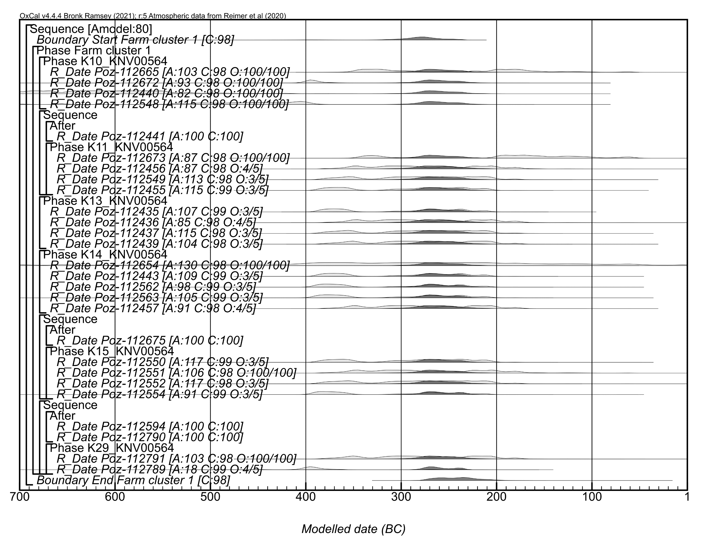
Figure S3.3: Component model for Farm cluster 1 (Model 1). The plot shows the model structure with calibrated non-modelled probabilities in light gray and the modelled posterior probabilities in dark gray for each sample. A values show OxCal agreement indices, which should be ≥ 60. C values show convergence, while O values show outlier posterior/prior probabilities (for samples with the Charcoal Plus Outlier model applied, these are always 100/100, while for the samples with the General Outlier model, the prior outlier probability is 5%).
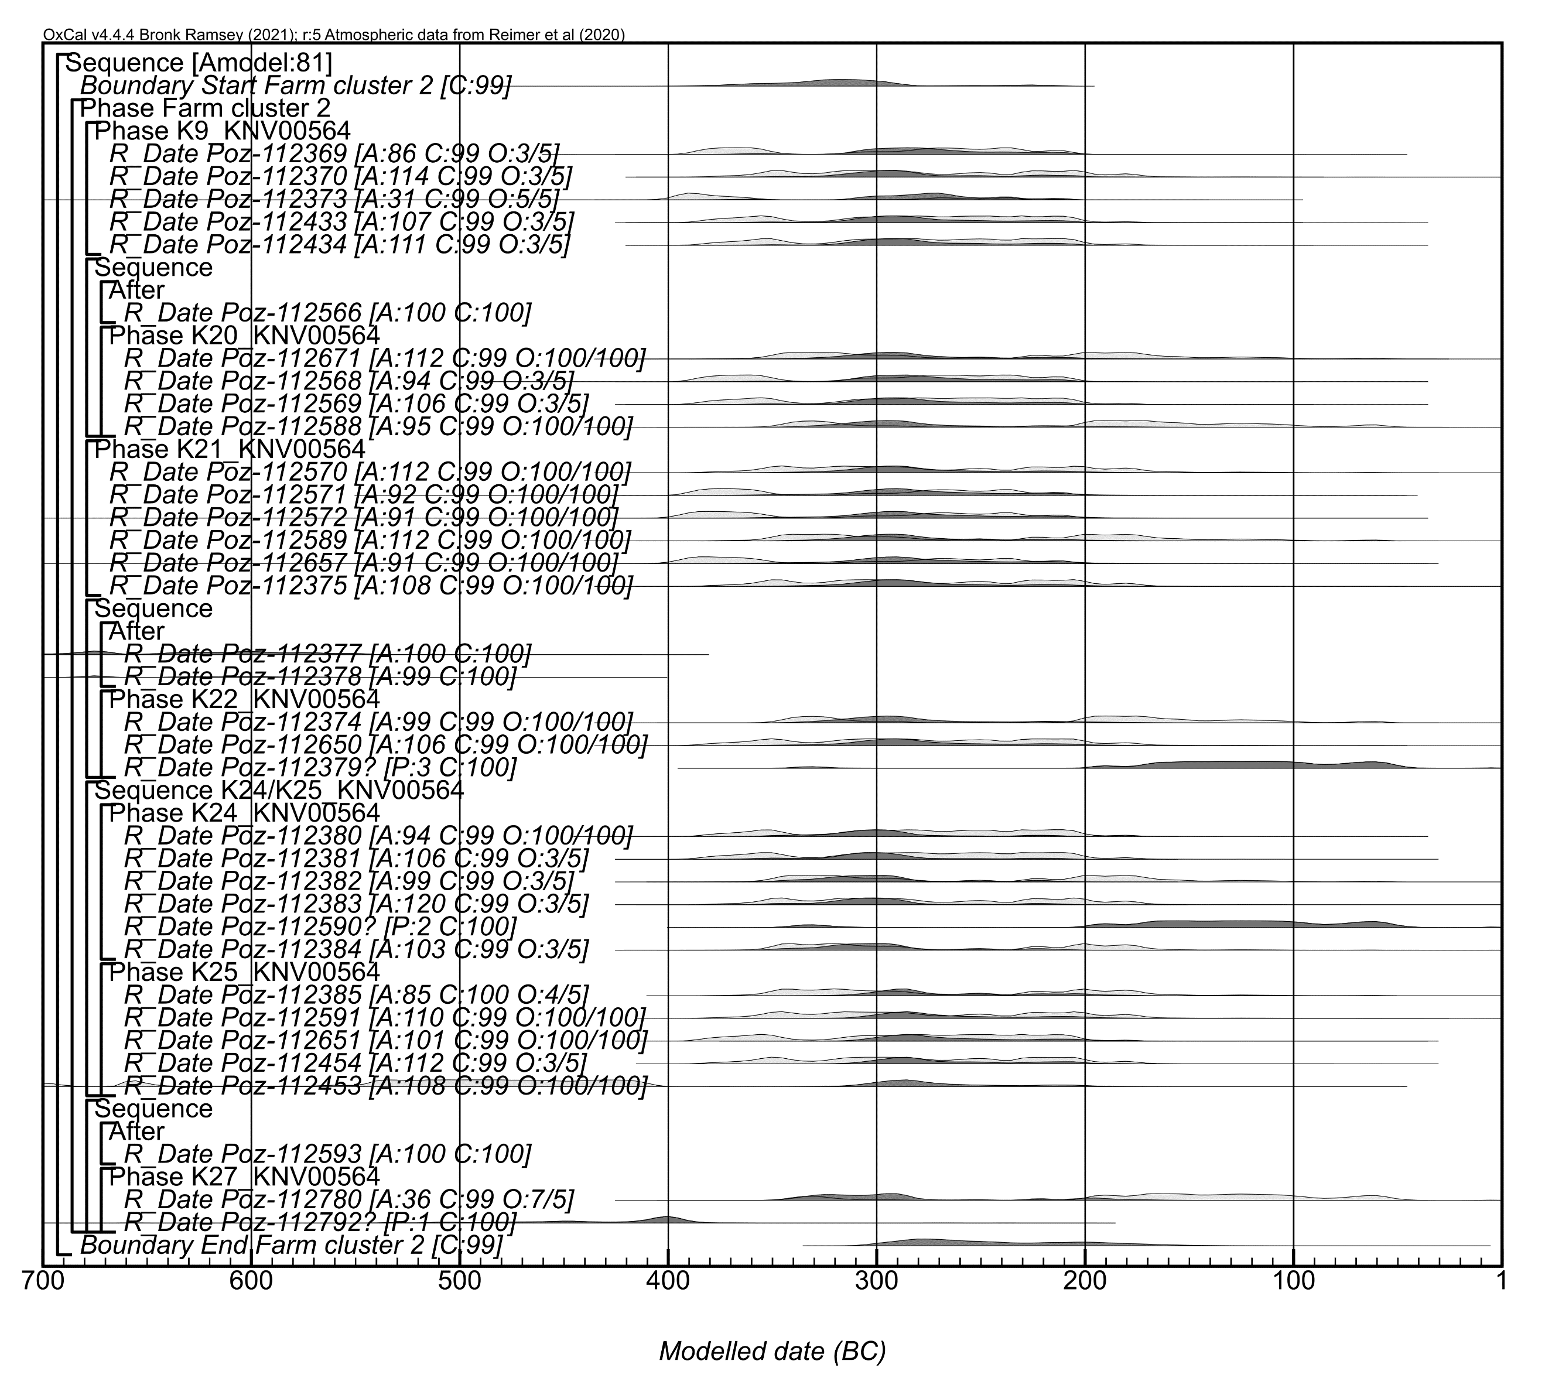
Figure S3.4: Component model for Farm cluster 2 (final Model 2 version). The format is identical to that used Figure S3.3.

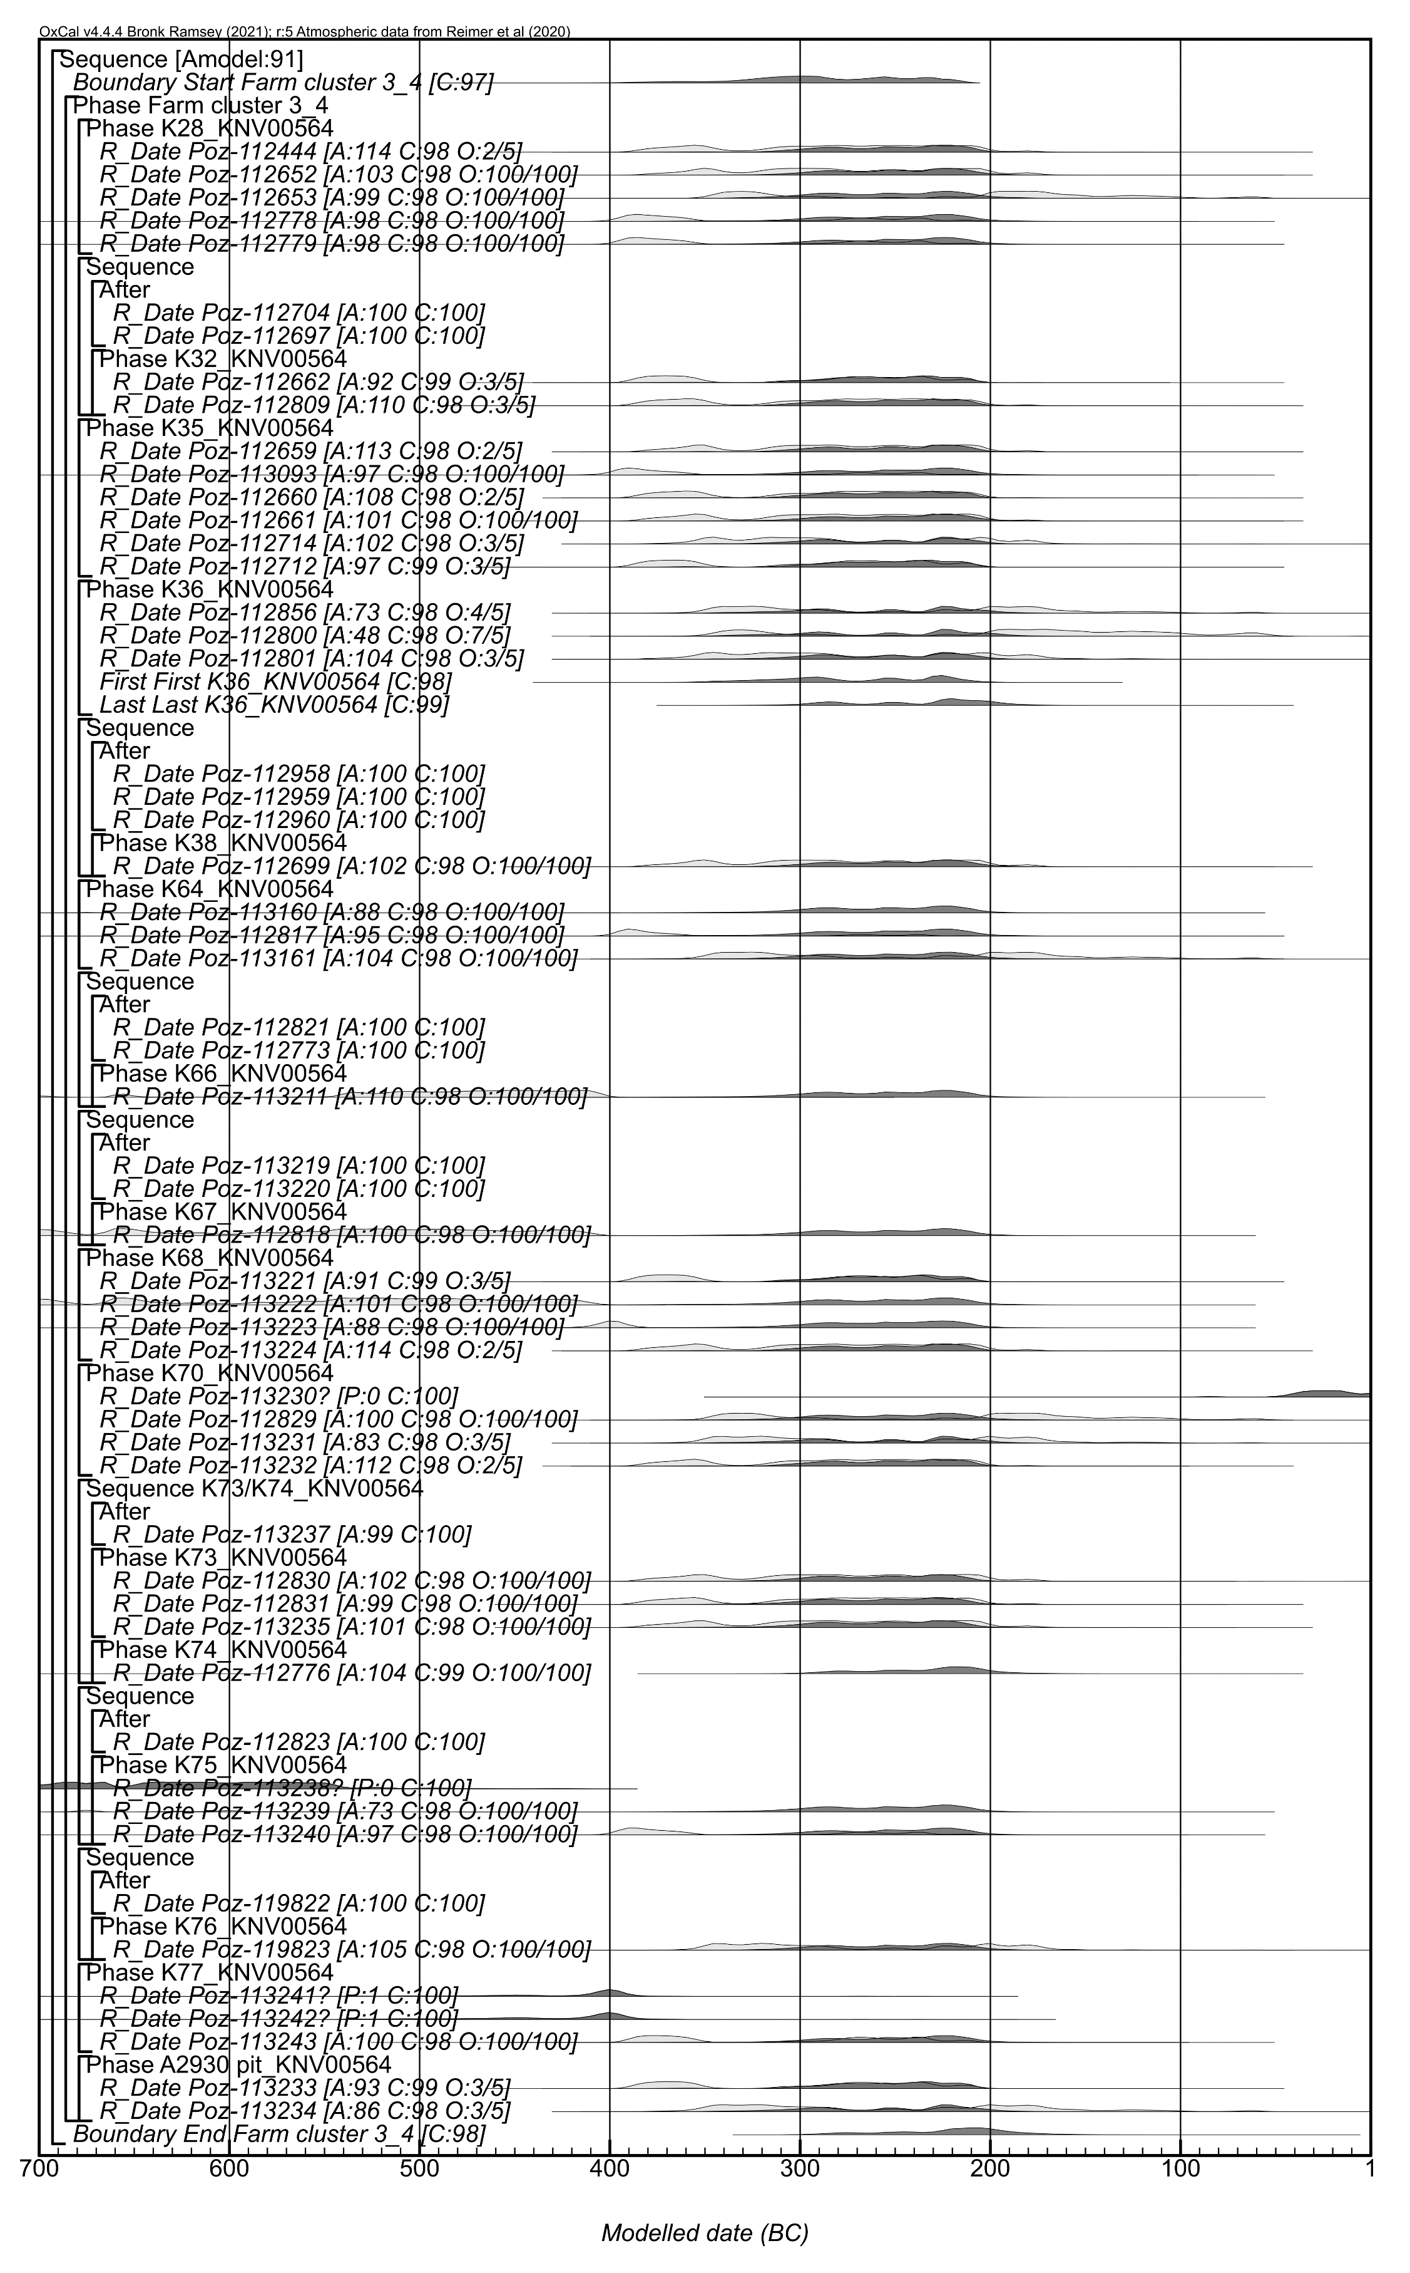
Figure S3.5: Component model for Farm cluster 3_4 (final Model 2 version). The format is identical to that used Figure S3.3.
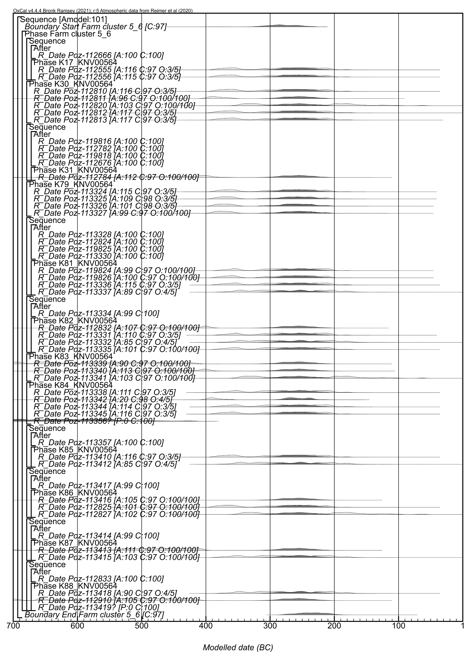
Figure S3.6: Component model for Farm cluster 5_6 (final Model 2 version). The format is identical to that used Figure S3.3.
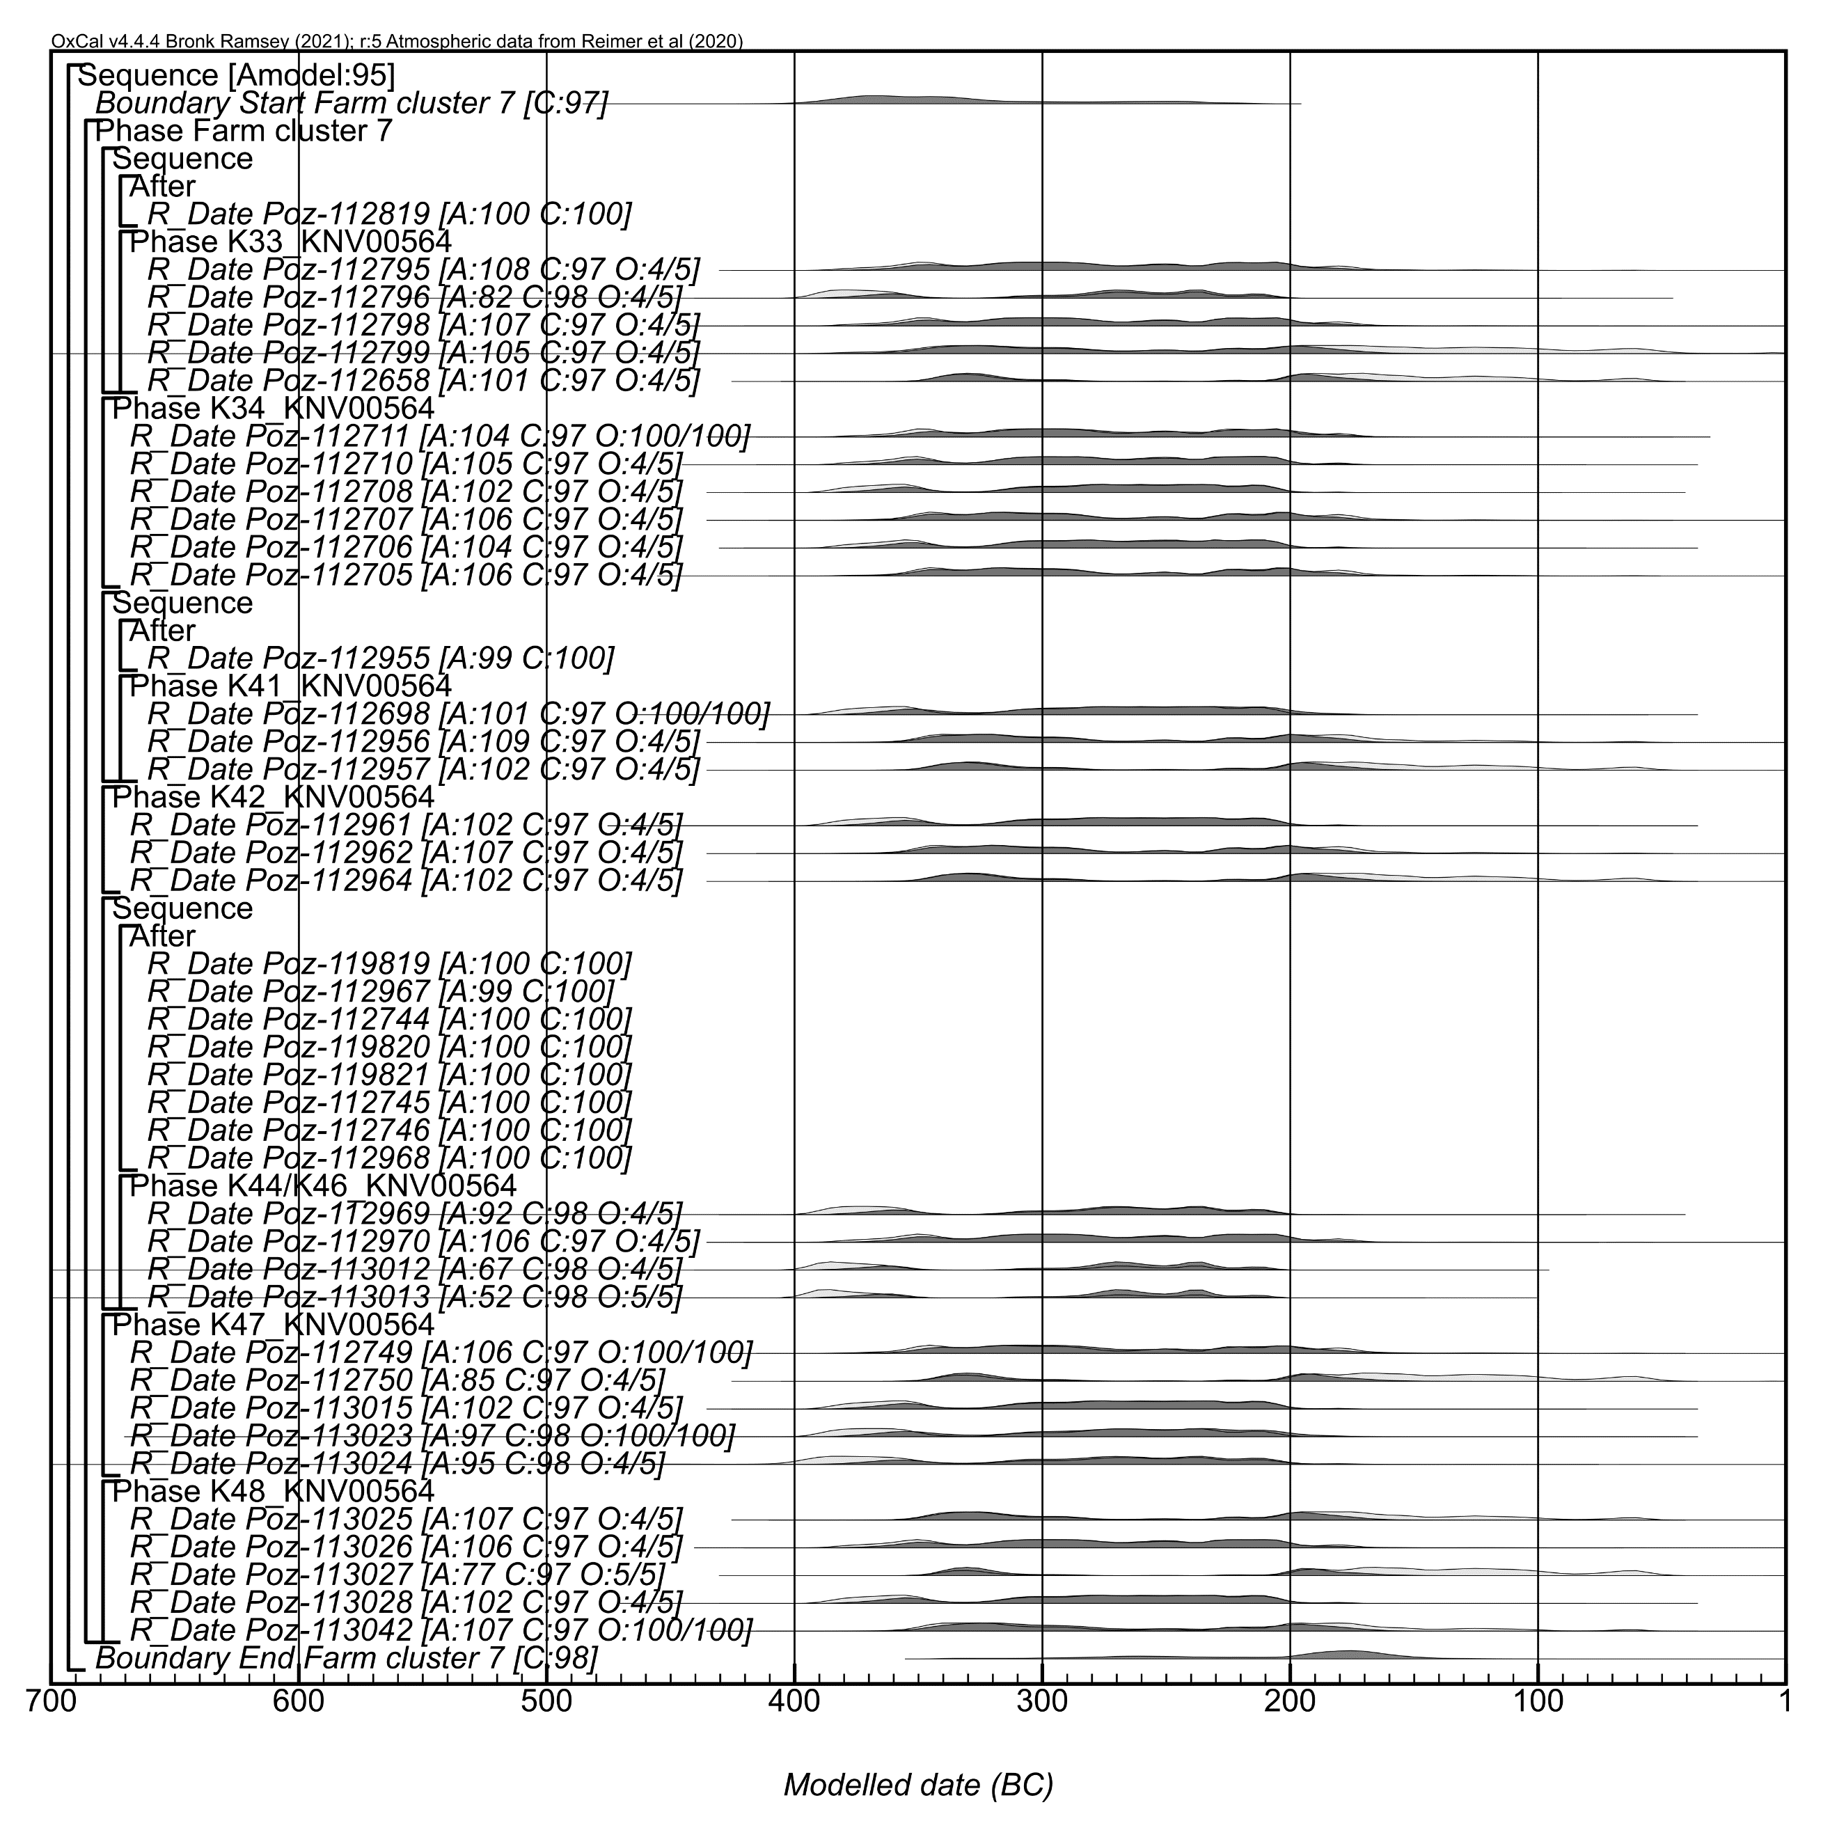
Figure S3.7: Component model for Farm cluster 7 (Model 1). The format is identical to that used Figure S3.3.
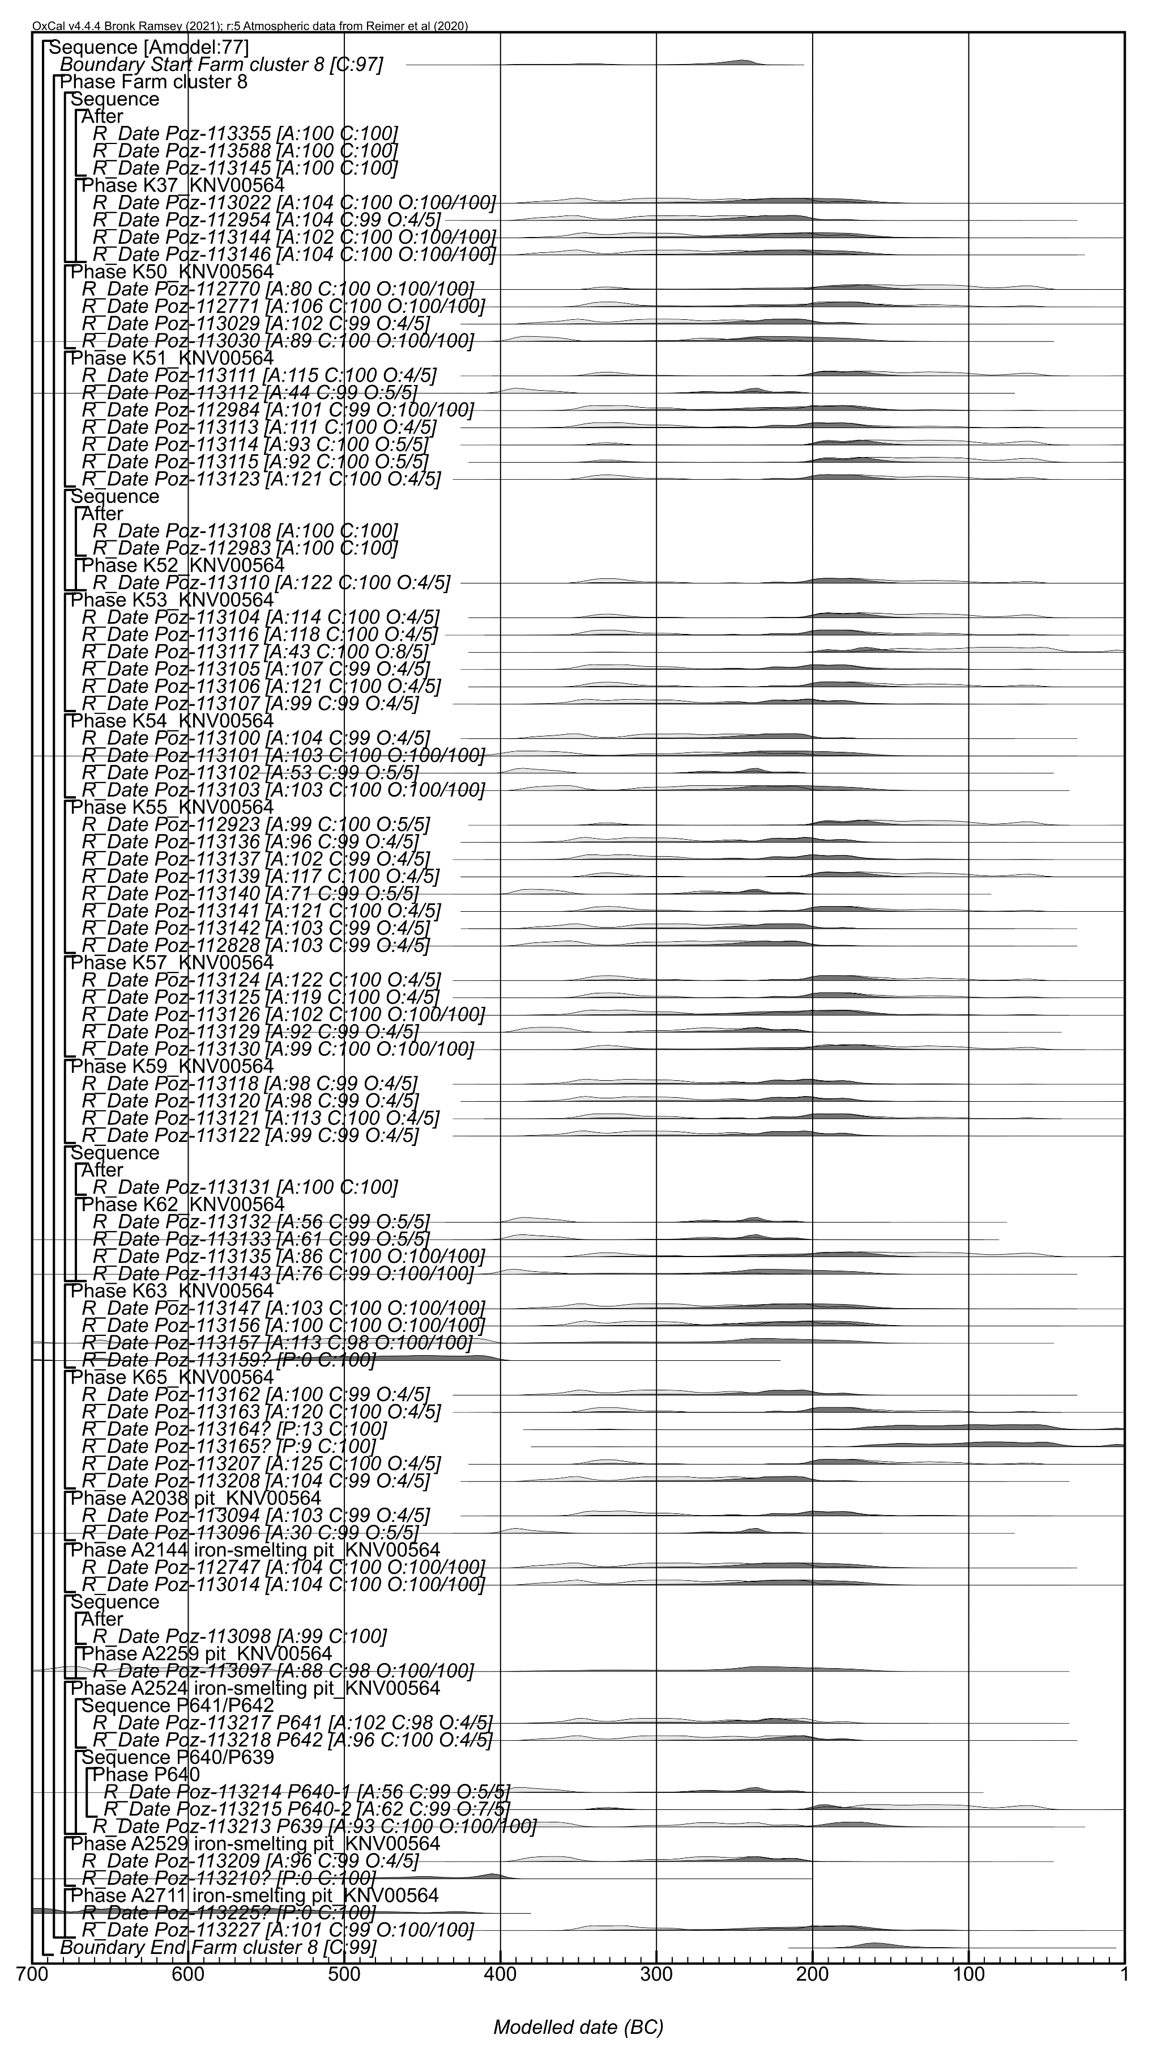
Figure S3.8: Component model for Farm cluster 8 (final Model 2 version). The format is identical to that used Figure S3.3.

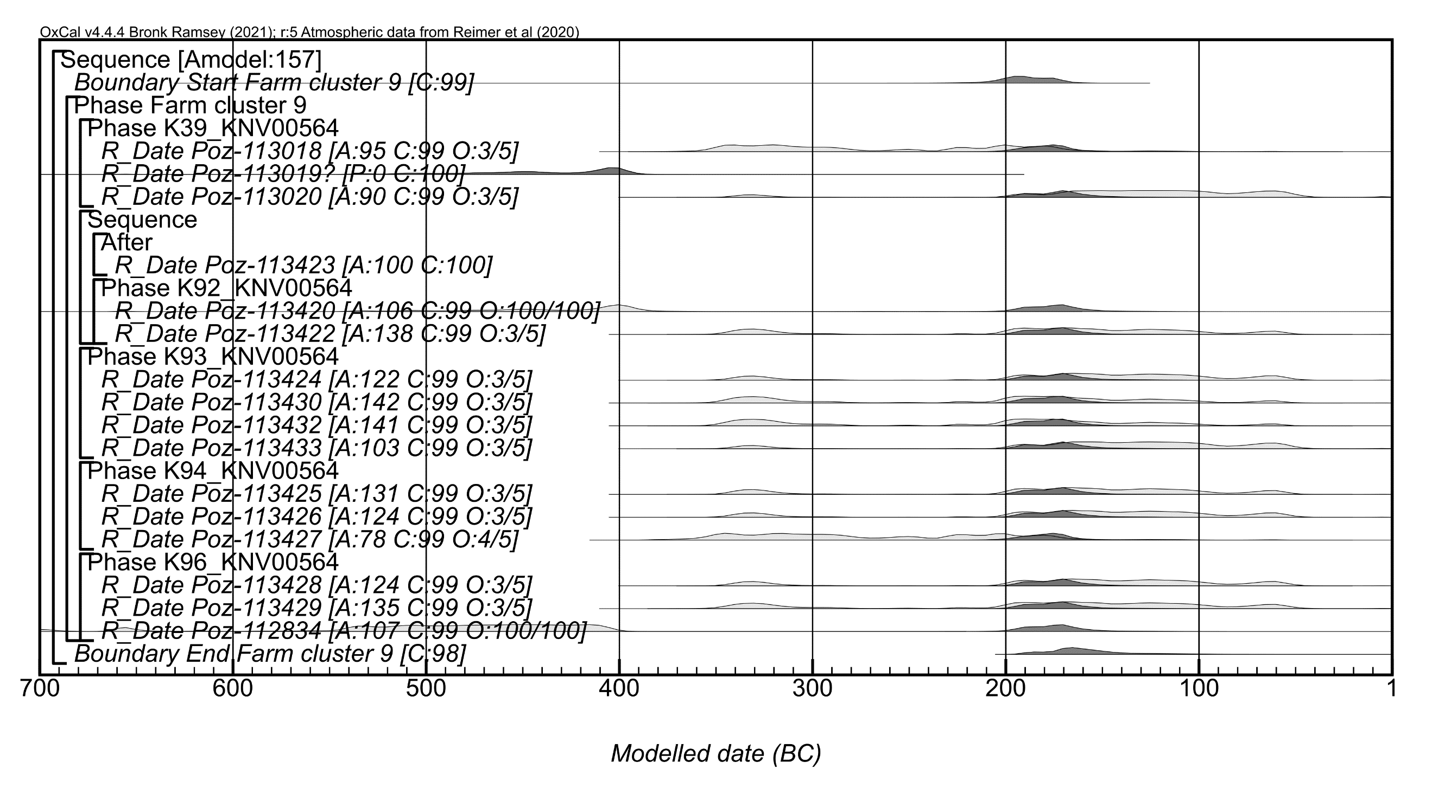
Figure S3.9: Component model for Farm cluster 9 (final Model 2 version). The format is identical to that used Figure S3.3.

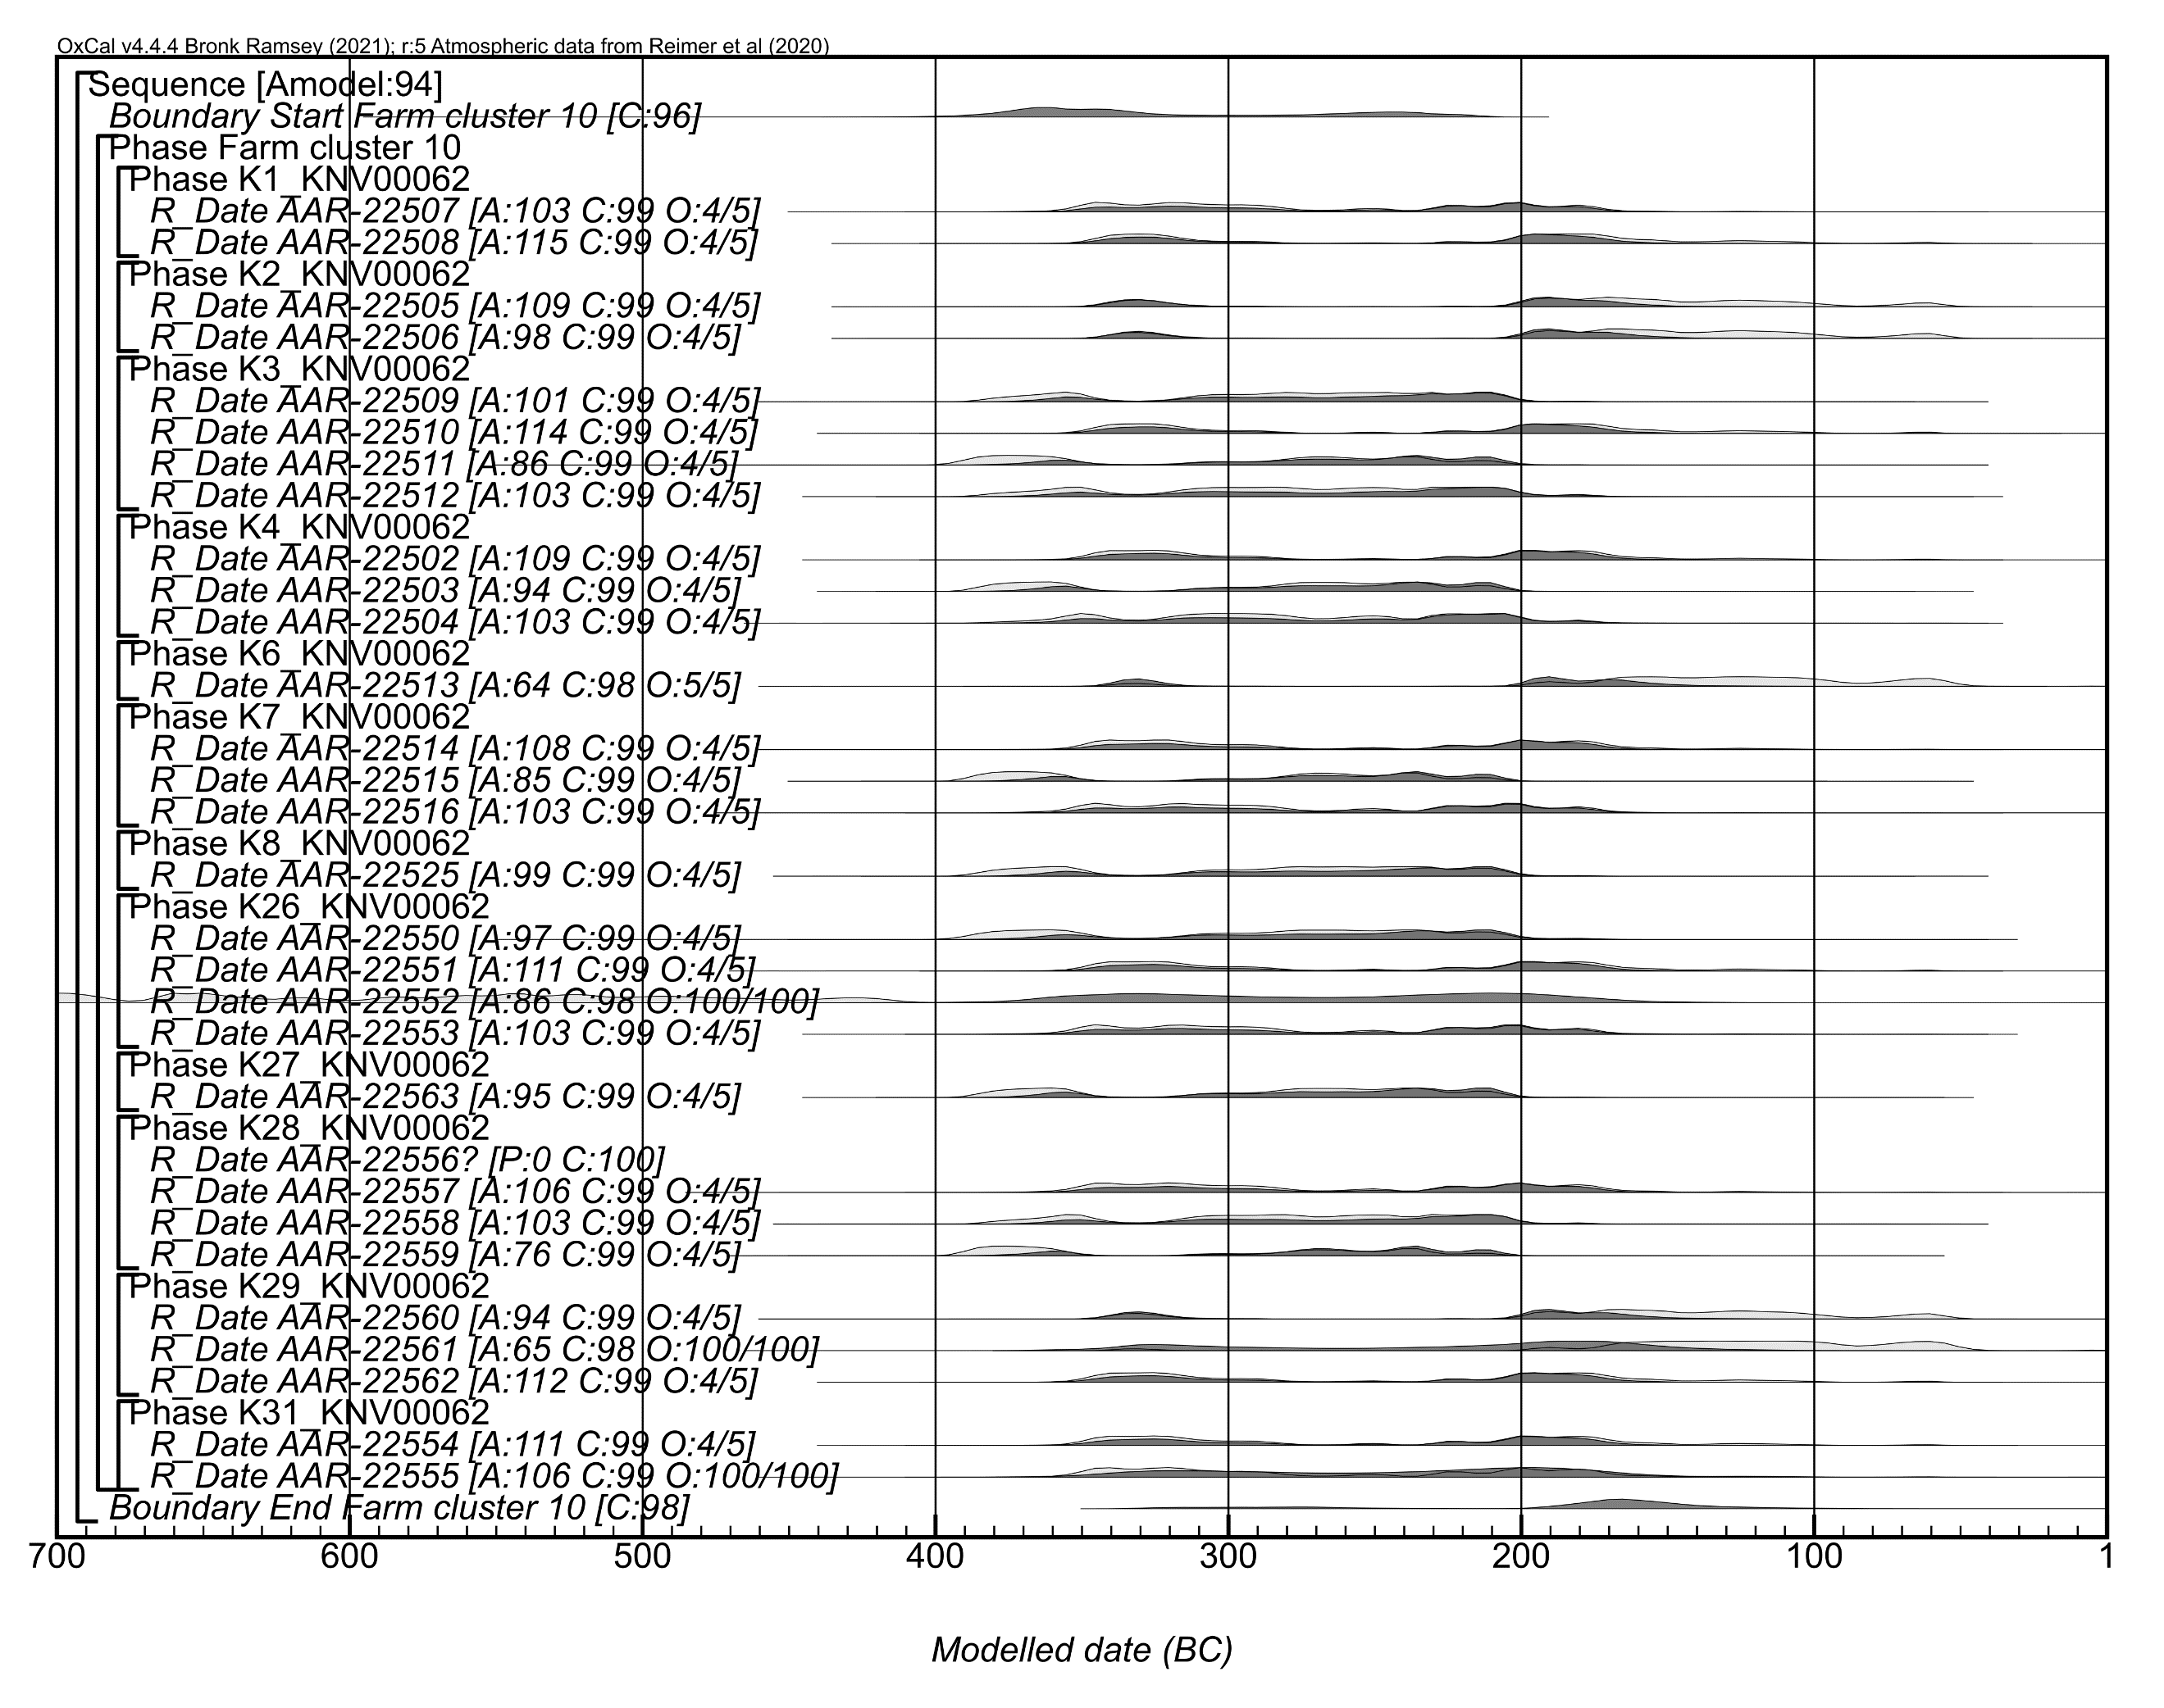
Figure S3.10: Component model for Farm cluster 10 (Model 1). The format is identical to that used Figure S3.3.

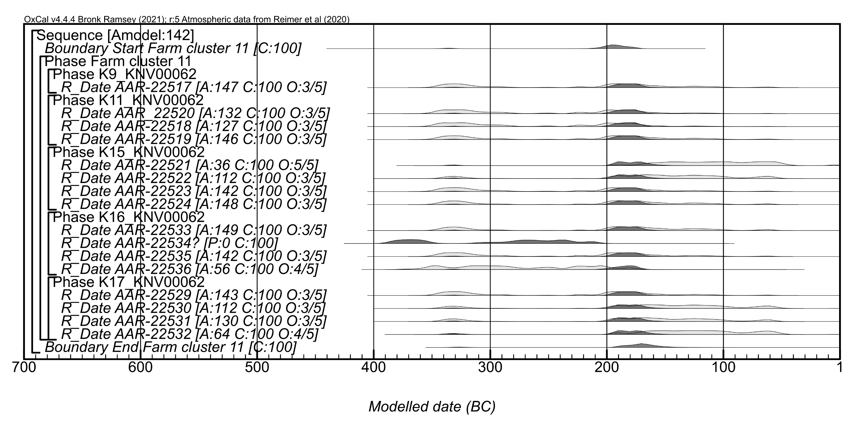
Figure S3.11: Component model for Farm cluster 11 (final Model 2 version). The format is identical to that used Figure S3.3.

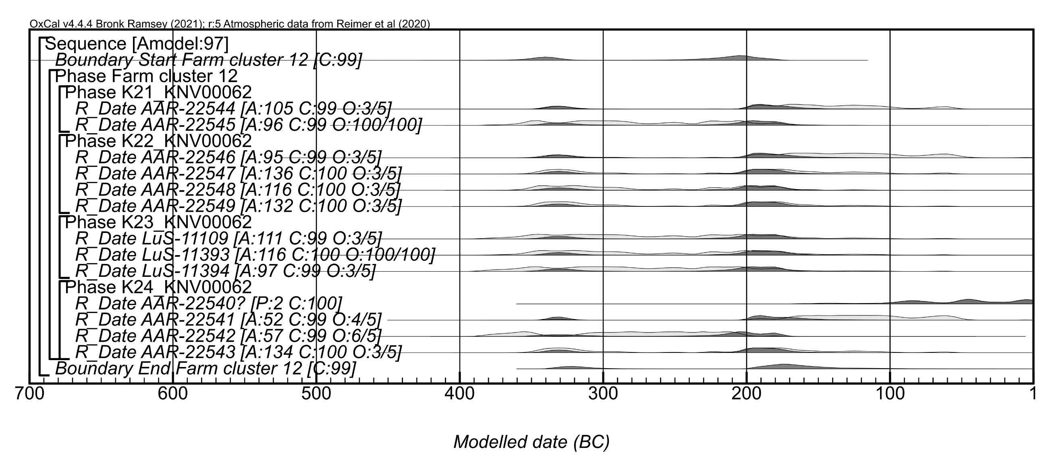
Figure S3.12: Component model for Farm cluster 12 (final Model 2 version). The format is identical to that used Figure S3.3.

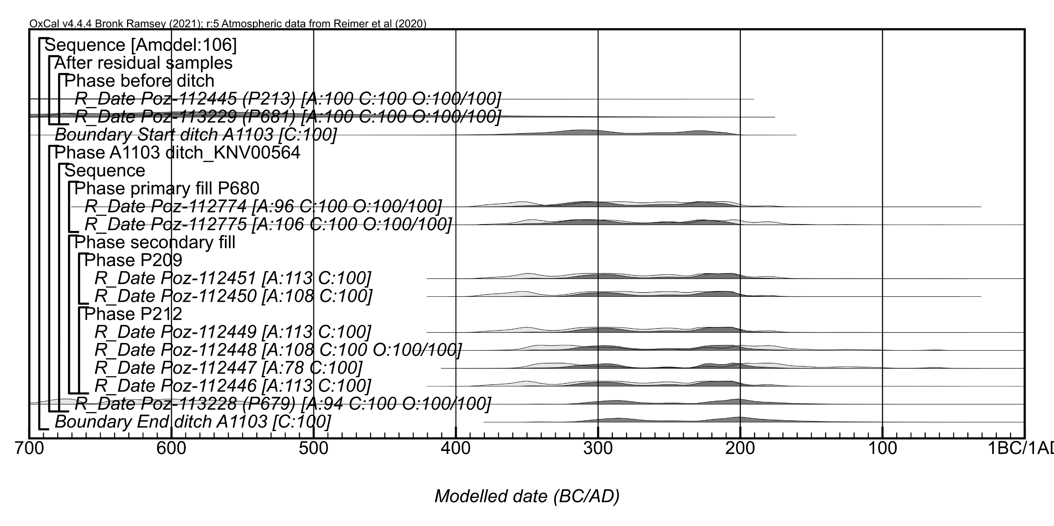
Figure S3.13: Component model for Ditch A1103 (Model 1). The format is identical to that used Figure S3.3.

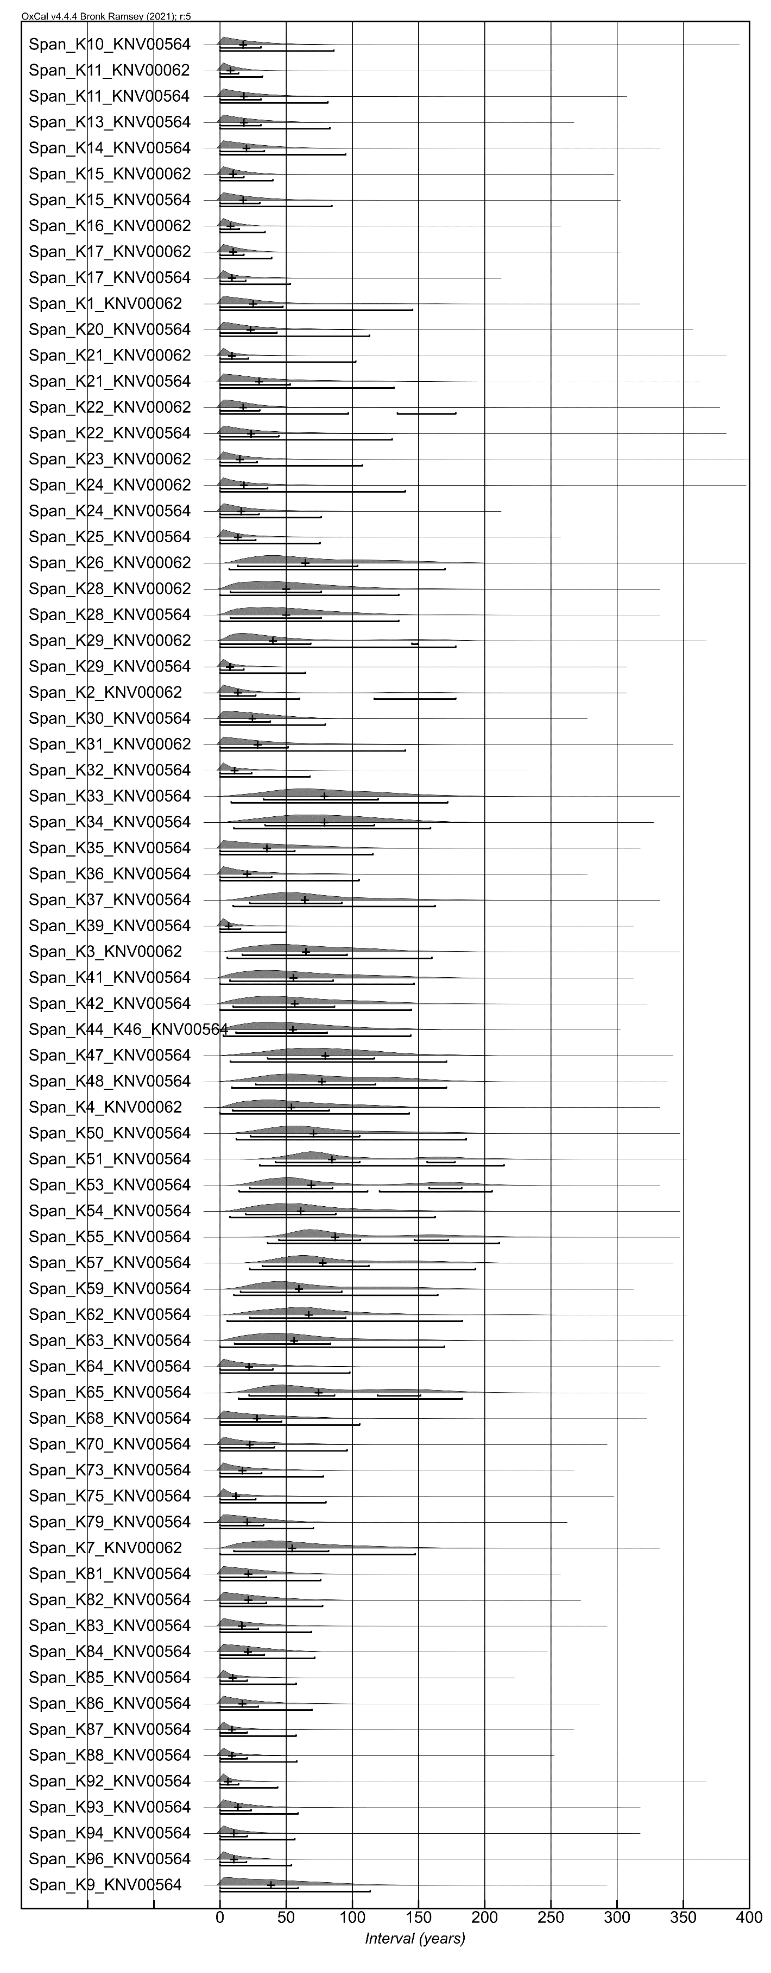
Figure S3.14: Span estimates for all house contexts with at least two radiocarbon dates in the final component Farm cluster model versions. Crosses show medians. The range bars below each distribution show the 68.3% and 95.4% ranges

