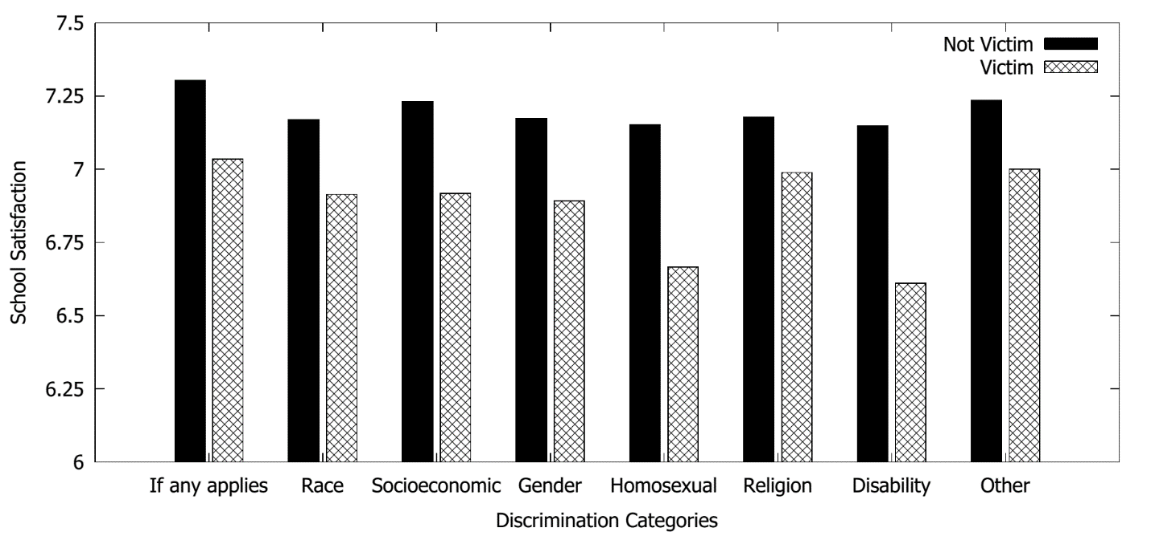
Figure 1: School satisfaction by different discrimination categories. Source: ENEM

