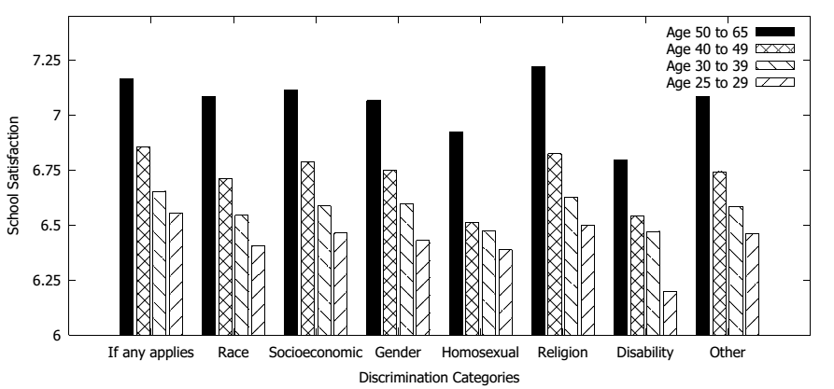
Figure 4: School satisfaction by perceived type of discrimination. Source: ENEM

