Article type: Research Article | Review Article | Conceptual Article | Methodological Article | Perspective and Vision Paper | Editorial
Title
Firstname Lastname ¹, Firstname Lastname ² and Firstname Lastname ^{2,}*
¹ Department, Institution, City, Country; name@institution.org; https://orcid.org/0000-0000-0000-0000
² Department, Institution, City, Country; name@institution.org; https://orcid.org/0000-0000-0000-0000
* Correspondence: name@institution.org; Tel.: (optional; include the country code). Give one corresponding author only.
EDITORIAL OFFICE USE ONLY — AUTHORS: DO NOT COMPLETE OR ALTER
Received: DD Month YYYY | Accepted: DD Month YYYY | Published: DD Month YYYY
Peer review: Single-anonymous, externally peer reviewed. Handling editor: Firstname Lastname.
Cite this article: Lastname, F., Lastname, F., & Lastname, F. (2026). Title of the article. Ecosystem Intelligence, 1, Article x. https://doi.org/10.xxxxx/ei.2026.0000
Copyright: © 2026 by the authors. Published by the University of Southern Denmark, hosted on tidsskrift.dk by the Royal Danish Library, under the CC BY 4.0 licence (https://creativecommons.org/licenses/by/4.0/).

Abstract
A single paragraph of 250 words maximum. For research articles, abstracts should give a pertinent overview of the work. We strongly encourage authors to use the following style of structured abstracts, but without headings: (1) Background: Place the question addressed in a broad context and highlight the purpose of the study. (2) Methods: Briefly describe the main methods or treatments applied. (3) Results: Summarize the article’s main findings. (4) Conclusions: Indicate the main conclusions or interpretations. The abstract should be an objective representation of the article and it must not contain results that are not presented and substantiated in the main text and should not exaggerate the main conclusions. State explicitly what the work contributes to ecosystem intelligence, and, where the work has an engineering, computing or technology contribution, make that visible here as well.
Keywords: keyword 1; keyword 2; keyword 3 (List three to eight pertinent keywords specific to the article yet reasonably common within the subject discipline). At least one keyword should locate the work within the scope of the journal.

0. How to Use This Template
This template must be used for all submissions to Ecosystem Intelligence. Manuscripts that do not use the template, or do not follow its formatting requirements, will be returned before editorial assessment.
Replace the example text with your own content while retaining the supplied styles and formatting. Do not redesign the title block, headings, figures, tables, equations, references or declarations.
Fields shown in the grey “Editorial Office Use Only” box, together with the journal header, footer, DOI and eISSN fields, are completed by the Editorial Office after acceptance and must not be edited by authors.
Delete instructional text marked [Author instruction …] before submitting the manuscript, and delete this section: your manuscript begins at Section 1.
Provide the complete affiliation for every author in the format shown above — department, institution, city and country, an institutional e-mail address and an ORCID iD. Do not change the order, labels or formatting of the author and affiliation block. Give one corresponding author only.
Write the title, abstract and keywords in English and give all bibliographic information in Roman script. Keep to the word limit for your article type, excluding the reference list: Research Article 7,000–12,000; Review Article 8,000–15,000; Conceptual Article 7,000–12,000; Methodological Article 7,000–12,000; Perspective and Vision Paper 3,000–6,000; Editorial, as agreed with the editors. Every type except Editorials requires an abstract of no more than 250 words and three to eight keywords. You may switch on line numbering (Layout → Line Numbers) for the review version. Questions: submissions@ecosystemintelligence.academy.
Research Articles should normally follow Sections 1–5 below. Review Articles, Conceptual Articles, Methodological Articles, and Perspective and Vision Papers may adapt Sections 2–5 to suit the article type while retaining the journal’s heading styles and numbering.

1. Introduction
The introduction should briefly place the study in a broad context and highlight why it is important. It should define the purpose of the work and its significance. The current state of the research field should be carefully reviewed and key publications cited. Please highlight controversial and diverging hypotheses when necessary. Finally, briefly mention the main aim of the work and highlight the principal conclusions. As far as possible, please keep the introduction comprehensible to scientists outside your particular field of research.
Sources are cited in author–date form following APA 7th edition. A work by one author is cited as (Andersen, 2025); by two authors as (Andersen & Bruun, 2025), using an ampersand inside the parentheses and “and” when the names run on in the sentence: Andersen and Bruun (2025) showed that…; and by three or more authors as (Christensen et al., 2024). Two or more works cited at the same point go inside a single pair of parentheses, ordered alphabetically as in the reference list and separated by semicolons: (Andersen, 2025; Bruun & Dahl, 2023; Christensen et al., 2024). Several works by the same author are combined and ordered by year, (Andersen, 2019, 2025), and works by the same author in the same year are distinguished by letters, (Andersen, 2025a, 2025b). For a direct quotation, add the page number: (Andersen, 2025, p. 12). See the References section for the corresponding list format.

2. Materials and Methods
The Materials and Methods should be described with sufficient detail to allow others to replicate and build on the published results. Please note that the publication of your manuscript implies that you must make all materials, data, computer code, and protocols associated with the publication available to readers. Please disclose at the submission stage any restrictions on the availability of materials or information. New methods and protocols should be described in detail while well-established methods can be briefly described and appropriately cited.
Research manuscripts reporting large datasets that are deposited in a publicly available database should specify where the data have been deposited and provide the relevant accession numbers. If the accession numbers have not yet been obtained at the time of submission, please state that they will be provided during review. They must be provided prior to publication.
Interventionary studies involving animals or humans, and other studies that require ethical approval, must list the authority that provided approval and the corresponding ethical approval code.
Where generative artificial intelligence or AI-assisted tools form part of the methodology — for example in study design, data generation, data collection, analysis or interpretation — describe that use here as you would any other method, naming the tool and its version. Formal disclosure of AI use is made in the Use of Generative AI statement.

3. Results
This section may be divided by subheadings. It should provide a concise and precise description of the experimental results, their interpretation, and the experimental conclusions that can be drawn.

3.1. Subsection

3.1.1. Subsubsection
Bulleted lists look like this:
- First bullet;
- Second bullet;
- Third bullet.
Numbered lists can be added as follows:
- First item;
- Second item;
- Third item.
The text continues here.

Formatting examples: figures, tables and schemes
[Formatting example — delete this heading and any unused examples before submission. Copy the example you need into the relevant part of your manuscript.]
All figures and tables should be cited in the main text as Figure 1, Table 1, etc.
Figures, tables or extended quotations reproduced or adapted from a copyrighted source require written permission from the rights holder before acceptance, and the source must be credited in the caption, for example “Reproduced from Author (2024) with permission”. Because articles are published under CC BY 4.0, material that cannot be licensed on those terms cannot be included.
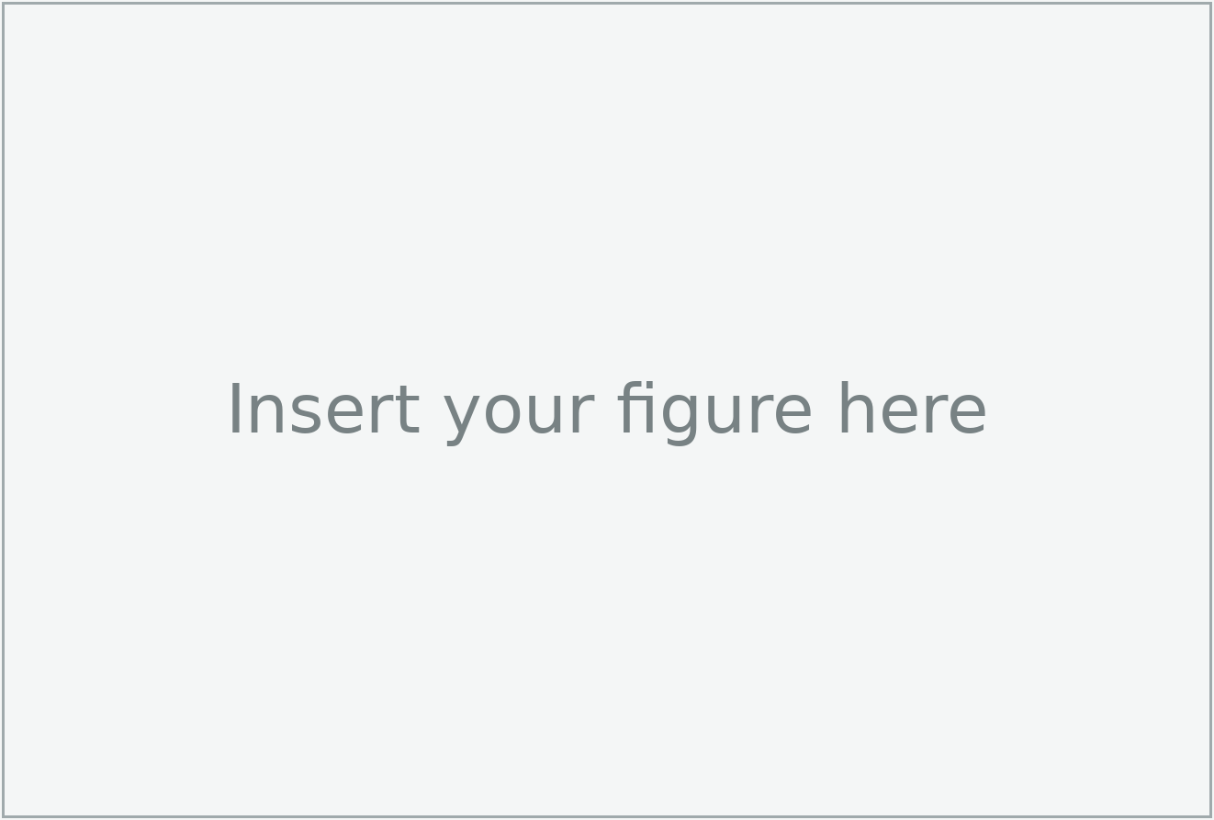
Figure 1. This is a figure. Schemes follow the same formatting.
Table 1. This is a table. Tables should be placed in the main text near the first time they are cited.
Title 1 | Title 2 | Title 3
entry 1 | data | data
entry 2 | data | data ¹
¹ Tables may have a footer.
A multi-panel figure and a table with merged cells follow.

(a) | (b)
Figure 2. This is a figure. Schemes follow the same formatting. If there are multiple panels, they should be listed as follows: (a) Description of what is contained in the first panel. (b) Description of what is contained in the second panel. Figures should be placed in the main text near the first time they are cited.
Table 2. This is a table. Tables should be placed in the main text near the first time they are cited.
Title 1 | Title 2 | Title 3 | Title 4
entry 1 * | data | data | data
entry 1 * | data | data | data
entry 1 * | data | data | data
entry 2 | data | data | data
entry 2 | data | data | data
entry 3 | data | data | data
entry 3 | data | data | data
entry 3 | data | data | data
entry 3 | data | data | data
entry 4 | data | data | data
entry 4 | data | data | data
* Tables may have a footer.

Formatting examples: equations, theorems and proofs
[Formatting example — delete this heading and any unused examples before submission. Copy the example you need into the relevant part of your manuscript.]
This is example 1 of an equation:
$a=1$, | (1)
the text following an equation need not be a new paragraph if it continues a sentence. Please punctuate equations as regular text.
This is example 2 of an equation:
$a=b+c+d+e+f+g+h+i+j+k+l+m+n+o+p+q+r+s+t+u+v+w+x+y+z$ | (2)
If the text following an equation starts a new sentence, it should be a new paragraph. Please punctuate equations as regular text.
Theorem-type environments (including propositions, lemmas, corollaries, etc.) can be formatted as follows:
Theorem 1. Example text of a theorem. Theorems, propositions, lemmas, etc., should be numbered sequentially (i.e., Proposition 2 follows Theorem 1). Examples or Remarks use the same formatting, but should be numbered separately, so a document may contain Theorem 1, Remark 1 and Example 1.
The text continues here. Proofs must be formatted as follows:
Proof of Theorem 1. Text of the proof. Note that the phrase “of Theorem 1” is optional if it is clear which theorem is being referred to. Always finish a proof with the following symbol. □
The text continues here.

4. Discussion
Authors should discuss the results and how they can be interpreted from the perspective of previous studies and of the working hypotheses. The findings and their implications should be discussed in the broadest context possible. Future research directions may also be highlighted.

5. Conclusions
This section is not mandatory but can be added to the manuscript if the discussion is unusually long or complex.

Supplementary Materials (if applicable)
The following supplementary materials are available at [DOI or persistent URL]: Figure S1: [title]; Table S1: [title]; Video S1: [title]; Dataset S1: [description]; [other supplementary item: description].
[Author instruction: Complete this section only if supplementary materials accompany the article. Ecosystem Intelligence and Tidsskrift.dk do not host supplementary files. Authors must deposit supplementary materials in a reliable external repository and provide the repository name and a stable public link, preferably a DOI or other persistent identifier. All supplementary items must be cited in the main text and accessible at the time of submission and publication. Delete this section if not applicable. Delete this instruction before submission.]

Author Contributions
Contributions are described with the fourteen roles of the CRediT taxonomy (ANSI/NISO Z39.104-2022, credit.niso.org). Use the role names exactly as given there, each followed by the initials of the authors concerned; an author may hold several roles and a role may be shared. Omit any role that does not apply. Authorship is limited to those who contributed substantially to the work reported and who approve the submitted version; anyone else — technical assistance, language editing, provision of materials or funding administration only — should be named in the Acknowledgments instead.
Example: Conceptualization, A.B. and C.D.; Methodology, A.B.; Software, C.D.; Validation, A.B., C.D. and E.F.; Formal analysis, A.B.; Investigation, C.D.; Resources, E.F.; Data curation, C.D.; Writing – original draft, A.B.; Writing – review & editing, C.D. and E.F.; Visualization, A.B.; Supervision, E.F.; Project administration, A.B.; Funding acquisition, E.F. All authors have read and agreed to the published version of the manuscript.
Where two or more authors contributed equally, state this here, for example: “A.B. and C.D. contributed equally to this work.” Changes to authorship after submission require the written agreement of all authors.

Funding
State either “This research received no external funding” or “This research was funded by NAME OF FUNDER, grant number XXX”. Give the funder’s full registered name and the grant number exactly as awarded; the standard spelling of funder names can be checked at https://search.crossref.org/funding.

Institutional Review Board Statement
In this section, please add the Institutional Review Board Statement and approval number for studies involving humans or animals. You might choose to exclude this statement if the study did not require ethical approval. Please note that the Editorial Office might ask you for further information. Please add “The study was conducted in accordance with the Declaration of Helsinki, and approved by the Institutional Review Board (or Ethics Committee) of NAME OF INSTITUTE (protocol code XXX and date of approval).” for studies involving humans OR “The animal study protocol was approved by the Institutional Review Board (or Ethics Committee) of NAME OF INSTITUTE (protocol code XXX and date of approval).” for studies involving animals OR “Ethical review and approval were waived for this study due to REASON (please provide a detailed justification).” OR “Not applicable.” for studies not involving humans or animals.

Informed Consent Statement
Any research article describing a study involving humans should contain this statement. Please add “Informed consent was obtained from all subjects involved in the study.” OR “Patient consent was waived due to REASON (please provide a detailed justification).” OR “Not applicable.” for studies not involving humans. You might also choose to exclude this statement if the study did not involve humans.
Written informed consent for publication must be obtained from participating patients who can be identified (including by the patients themselves). Please state “Written informed consent has been obtained from the patient(s) to publish this paper.” if applicable.

Data and Code Availability Statement
It is mandatory for the authors to include a “Data Availability Statement (DAS)” section in their manuscripts, except for Editorials. In this section, authors are required to provide details regarding where data supporting their reported results can be found, including links to publicly archived datasets analyzed or generated during the study. Where no new data were created or where data is unavailable due to privacy, legal, or ethical restrictions, a statement is still required. Suggested Data Availability Statements are available in the journal’s research data policy at https://tidsskrift.dk/JournalEcosystemIntelligence/about.
Software, models and analysis code underpinning the results should be deposited in a public repository under an open licence, and the statement must give the repository, the version and the persistent identifier, for example: “The analysis code is available at https://doi.org/10.xxxx/zenodo.xxxxx (v1.0, MIT licence).” Deposited datasets and code are also cited in the reference list.

Use of Generative AI
This statement is mandatory. State whether generative artificial intelligence or AI-assisted technologies were used in the preparation of the work, naming the tool and its version and describing what it was used for, or state “Not applicable”. Example: “During the preparation of this manuscript the authors used [tool, version] for [purpose]. The authors reviewed and edited the output and take full responsibility for the content of this publication.” AI tools cannot be listed as authors, cannot be cited as a source of scientific evidence, and their use for superficial language editing need not be declared.

Acknowledgments
In this section, you can acknowledge any support given that is not covered by the author contribution or funding sections. This may include administrative and technical support, or donations in kind (e.g., materials used for experiments).

Conflicts of Interest
Declare conflicts of interest or state “The authors declare no conflicts of interest.” Authors must identify and declare any personal circumstances or interests that may be perceived as inappropriately influencing the representation or interpretation of reported research results. Any role of the funders in the design of the study; in the collection, analyses or interpretation of data; in the writing of the manuscript; or in the decision to publish the results must be declared in this section. If there is no role, please state “The funders had no role in the design of the study; in the collection, analyses, or interpretation of data; in the writing of the manuscript; or in the decision to publish the results”.

Abbreviations
The following abbreviations are used in this manuscript:
ABM | Agent-based model
IoT | Internet of Things
LCA | Life-cycle assessment
ML | Machine learning

Appendix

Appendix A
The appendix is an optional section that can contain details and data supplemental to the main text—for example, explanations of experimental details that would disrupt the flow of the main text but nonetheless remain crucial to understanding and reproducing the research shown; figures of replicates for experiments of which representative data are shown in the main text can be added here if brief, or as Supplementary Materials. Mathematical proofs of results not central to the paper can be added as an appendix.
Table A1. This is a table caption.
Title 1 | Title 2 | Title 3
entry 1 | data | data
entry 2 | data | data

Appendix B
All appendix sections must be cited in the main text. In the appendices, figures, tables, etc., should be labeled starting with “A”, e.g., Figure A1, Figure A2, etc.

References
References follow the Publication Manual of the American Psychological Association, 7th edition (APA 7th). The list is arranged alphabetically by the surname of the first author, is not numbered, and uses a hanging indent. List up to 20 authors; for 21 or more, give the first 19, then an ellipsis, then the final author. Include the DOI of every source that has one, written as a full https://doi.org/ link. Preparing the list with a reference manager (Zotero, EndNote or Mendeley) using the APA 7th style is strongly recommended. Citations that appear only in the Supplementary Materials must also be listed here. Cite sources because they are relevant to your argument. Ecosystem Intelligence never requires citations to itself as a condition of acceptance, and authors are free to decline a reviewer’s suggestion to add references, including to the reviewer’s own work.
Author, A. A. (2023). Title of the book: Subtitle in sentence case (3rd ed.). Publisher. https://doi.org/10.xxxx/xxxxx
Author, A. A., & Author, B. B. (2024). Title of the chapter. In C. C. Editor & D. D. Editor (Eds.), Title of the edited book (2nd ed., pp. 154–196). Publisher.
Author, A. A., Author, B. B., & Author, C. C. (2025). Title of the journal article. Journal Name, 12(3), 123–145. https://doi.org/10.xxxx/xxxxx
Author, A. A., & Author, B. B. (2027). Title of an article in a journal that uses article numbers instead of page ranges. Ecosystem Intelligence, 1, Article 7. https://doi.org/10.xxxxx/ei.2027.0007
Author, A. A., & Author, B. B. (2025, June 10–13). Title of the conference contribution [Conference paper]. Name of the Conference, City, Country. https://doi.org/10.xxxx/xxxxx
Author, A. A. (2024). Title of the dataset (Version 1.0) [Data set]. Repository Name. https://doi.org/10.xxxx/xxxxx
Author, A. A. (2024). Title of the doctoral thesis [Doctoral dissertation, Name of University]. Repository Name. https://url
Author, A. A. (2026). Title of the preprint [Preprint]. Server Name. https://doi.org/10.xxxx/xxxxx
Organisation Name. (2025). Title of the report (Report No. 123). Publisher. https://url
Organisation Name. (2026, March 2). Title of the web page. Site Name. Retrieved 13 August 2026, from https://url

